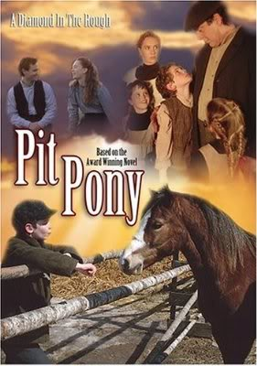**Pit Pony News!**

**Individual & Group Project for 5W**

Now that you have finished reading *Pit Pony*, it’s time to show the class what you’ve learned! In the next week, you will get a chance to research topics that interest you (and that relate to the novel), write a couple of interesting articles, and demonstrate your great acting skills as your group gives us your Pit Pony News Report.

1. Each person must write 4 articles, with the following segments:C:\Documents and Settings\kwarnock\Local Settings\Temporary Internet Files\Content.IE5\VIQCBO3N\MCj01493200000[1].wmf
2. **Major News Stories**
   * Cape Breton
     + Mine stories & events, etc.
   * Sable Island
     + Feature on horses & pit ponies
   * Nova Scotia
     + News from around the province
3. **Interview with the author** and/or **Interview with a character**
   * Pretend that Joyce lived in Cape Breton in 1902 and just finished writing a book about an amazing even that happened there!
   * Interview Simon, the year after the accident to see how his life is different
4. C:\Documents and Settings\kwarnock\Local Settings\Temporary Internet Files\Content.IE5\VIQCBO3N\MCj01493260000[1].wmf**Around the World in 60 seconds**
   * Find out what happened around 1902 and give a brief report

1. **Local News**
   * **Weather Report**
   * **Sports cast**
   * **Commercials**
   * **Community Events**

You will receive both group and individual marks:

|  |  |
| --- | --- |
| **Group** | **Individual** |
| * Preparation   + Research   + Writing news stories   + Planning for props & costumes * Presentation   + Creative & Interesting   + Accurate & Informative   + Well rehearsed * Participation / Effort   + Equal distribution of work   + Working quietly & productively   + Working well together | * Writing   + Research (hand in notes)   + writing historically accurate stories & fictional stories   + Proper formatting for paragraphs, spelling, grammar * Presentation   + Public speaking, dramatic skills, oral fluency * Participation / Effort   + Working quietly, productively, and collaboratively (supportive) |

**GROUPS**:

|  |  |  |
| --- | --- | --- |
| Group 1 | Group 2 | Group 3 |
|  |  |  |
| Group 4 | Group 5 | Group 6 |
|  |  |  |

**Brainstorming**

1. After everyone has writing their 4 articles, decide on which articles your group will include for each segments of your newscast:
2. **2-3 Major News Stories** 
   * Cape Breton
   * Sable Island
   * Nova Scotia
3. **1-2 Interviews** 
   * Characters
   * Author
4. **1 Around the World in 60 seconds**
5. **2-4 Local News**
   * Weather Report
   * Sports cast
   * Commercials
   * Community Events
6. Props: Decide what props & costumes you need to bring, as well as what posters to make.

C:\Documents and Settings\kwarnock\Local Settings\Temporary Internet Files\Content.IE5\RW8OANNG\MCj01493470000[1].wmf

**Due date for individual articles: ______________ Due date for group performances: ______________**